Manual steps for setting up Journey dashboard

* Deploy the zip package in the destined account (preferably parent BU)

Note: Journey Dashboard must be separately deployed in each BU for which you would like to track engagement

* The DEs would be created under a folder – **Journey Dashboard**
* Update the Cloud page URLs DE details in the below manner with the Cloud page name field as the name of the Cloud page.

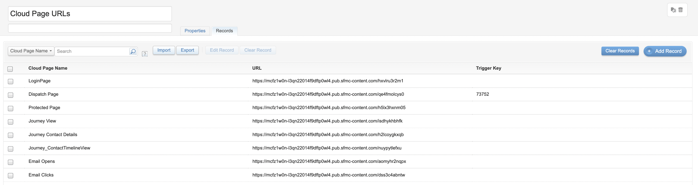

Create a triggered send definition with the Email - **Login_Token_Email**, set the priority to high, if you would like to receive the OTP email instantly. Choose the **TSD_Tokens_Auth** DE as the target DE

* Note: this consumes 4X super messages
* Update the Cloud page – Protected Page lines 449 and 452 with the URLs of journey view and Journey contact timeline view resp

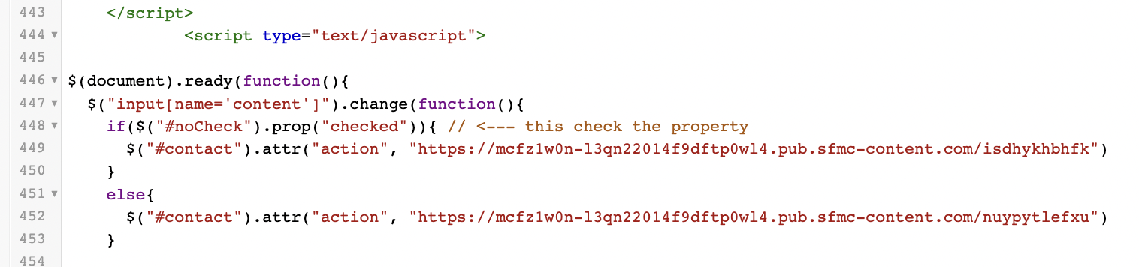

* Schedule the automation to run on hourly basis
* Always access the tool from the protected page.